GCSE TestBank

This document contains test questions assessing the statements of the National Curriculum Programmes of Study as referenced in the Kangaroo Maths Stage 10 scheme of work, and their prerequisites.

The questions are arranged in the same order as the units of the Kangaroo Maths Stage 10 scheme of work.

Most questions are very closely modeled on the AQA Specimen Papers published in June 2015.

Questions are coded as follows:

FC | Foundation paper, calculator allowed
FHC | Foundation and higher papers, calculator allowed
HC | Higher paper, calculator allowed
FN | Foundation paper, calculator not allowed
FHN | Foundation and higher papers, calculator not allowed
HN | Higher paper, calculator not allowed

A very small number of questions are based on specimen papers published by Edexcel or OCR. These questions do not have codes.

1 Simplify 4⁵ × 4⁷
Circle the answer.
[HN, 1 mark]

16³⁵ | 4¹² | 16¹² | 4³⁵

2 Work out $1\frac{2}{3}+3\frac{2}{5}$
Give your answer as a mixed number in its simplest form.
[FHN, 3 marks]

Answer

3 Patricia is trying to work out the values of q for which q(q² – 12) = 16
Her values are -2 and 4

Are Patricia’s values correct?
You must show your working.
[HN, 2 marks]

4 ABEH is a rectangle
BCDE is a square
EFGH is a square
The three shapes are joined to make an L-shape.
Not drawn accurately
A |  |  | B |  |  |  |  |  | C
 |  |  |  |  |  |  |  |  | (x + 2) cm
H
 |  |  |  | E |  |  |  |  | D
G | 4 cm |  |  | F

Show that the total area of the L-shape, in cm², is x² + 8x + 28
[FHN, 4 marks]

5 Here are sketches of four triangles

 | Not drawn accurately
2 cm  1.66 cm  34° | 2 cm  1.2 cm  34°
2 cm  34 °  1.12 cm | 1.17 cm  2 cm  34°
In each triangle
the longest side is exactly 2 cm
the other length is given to 2 decimal places

5 a) Circle the value of sin 34° to 2 decimal places.
[FHN, 1 mark]

0.84 | 0.6 | 0.56 | 0.585

5 b) Work out the value of x.
Give your answer to 1 decimal place.
Not drawn accurately
8 cm
x cm
34°

[FHN, 2 marks]

Answer

6 a × 10⁵ + a × 10³ = 181800 where a is a number

Work out a × 10⁴
Give your answer in standard form.
[HN, 2 mark]

Answer

7 Rectangle OABC is constructed on a coordinate grid.
O is the origin | A is (4, 0) | B is (4, 2) | C is (0, 2)

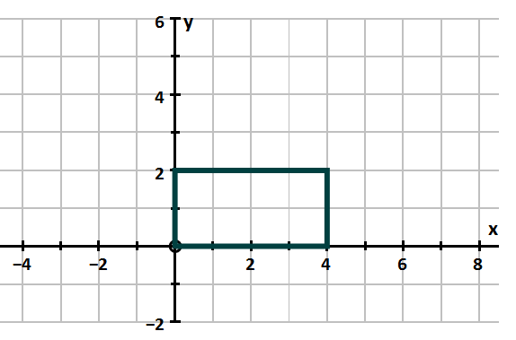

7 a) OABC is rotated 180°, centre (2, 1)

Circle the number of invariant points on the perimeter of the rectangle
[HN, 1 mark]

0 | 1 | 2 | 4

7 b) OABC is enlarged, scale factor 1.5, centre (0, 0)

Circle the number of invariant points on the perimeter of the rectangle
[HN, 1 mark]

0 | 1 | 2 | 4

7 c) OABC is reflected in the line y = 1

Circle the number of invariant points on the perimeter of the rectangle
[HN, 1 mark]

0 | 1 | 2 | 4

8 Show that 10 tan 60° + 2 sin 60° can be written in the form $a\sqrt{b}$ where a and b are integers

[HN, 3 marks]

9 Show that $\sqrt{108}$ can be written in the form $a\sqrt{3}$ where a is an integer.

[2 marks]

10 a) Write down the value of $9^{\frac{1}{2}}$
[1 mark]

Answer

10 b) Find the value of ${\left(\frac{1}{64}\right)}^{-\frac{2}{3}}$
[3 marks]

Answer

11 Work out the cube root of eight million.
Circle your answer.
[FHC, 1 mark]

20 | 200 | 2000 | 20000

12 Circle the decimal that is closest in value to $\frac{7}{9}$.
[FHC, 1 mark]

0.7 | 0.77 | 0.78 | 0.8

13 a) Use your calculator to work out $\frac{{12.42}^{2}+ \sqrt[3]{121}}{5.02}$

Write down your full calculator display.
[FHC, 1 mark]

Answer

13 b) Use approximations to check that your answer to part (a) is sensible.
You must show your working.
[FHC, 2 marks]

14 Use ruler and compasses to answer this question.

Point X is
- the same distance from lines AB and AC
- 5 cm from point A

B
A
C

Show the position of point X on the diagram
[FHC, 3 marks]

15 Tick whether each statement is true or false.
Give a reason for your answer.

15 a) If x² = 9, the only value that x can be is 3
[FHC, 1 mark]

 | True |  | False

Reason

15 b) When n is a positive integer, the value of 6n is always a multiple of 3n.
[HC, 1 mark]

 | True |  | False

Reason

15 c) When p is an integer, the value of p⁵ is always greater than the value of p.
[HC, 1 mark]

 | True |  | False

Reason

16 Circle the expression that is equivalent to –8b – 10b ÷ 2b + 3b
[HC, 1 mark]

–8b – 2 | –9 + 3b | –5(b – 1) | –5b – 5

17 Here is the graph of 5y − 3x = 15 for values of x from -5 to 6

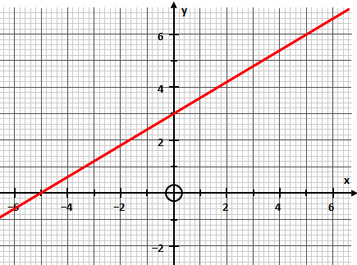

By drawing a second graph on the grid,
work out an approximate solution to the simultaneous equations

5y − 3x = 15 and 4x + 2y = 12
[HC, 3 marks]

Answer

18 Written as the product of its prime factors 560 = 2⁴ × 5 × 7

18 a) Write 450 as the product of its prime factors
[HC, 2 marks]

Answer

18 b) Work out the value of the highest common factor of 560 and 450.
[HC, 1 mark]

Answer

19 Factorise 5x² – 13x – 6
[HN, 2 marks]

Answer

20 In the formula C = (m + 3)³ + 8 m is an integer.

20 a) Lynette says,
“The value of C is always greater than 8
because (m + 3)³ is always greater than 0”

Comment on her statement.
[HC, 1 mark]

20 b) What is the only value of C that is a cube number?
[HC, 1 mark]

Answer

21 $T= \frac{a}{b^{2}}$
a = 2.4 × 10⁶
b = 2.5 × 10⁻²

Work out the value of T.
Give your answer in standard form to an appropriate degree of accuracy.
[HC, 3 marks]

Answer

22 Mercury orbits the sun in 88 days at an average speed of 1.72 × 10⁶ kmh⁻¹.
Pluto orbits the sun in 249 years at an average speed of 1.71 × 10⁴ kmh⁻¹.
Assume that their orbits are circles centred on the sun.

22 a) Work out the least distance between Mercury and Pluto at any time.
[HC, 4 marks]

Answer |  | km

22 b) Mercury’s speed has been rounded to three significant figures.

Write the lower and upper bounds of Mercury’s speed.
Give your answers as ordinary numbers.
[HC, 2 marks]

Lower bound |  | kmh⁻¹
Upper bound |  | kmh⁻¹

23 A theodolite is a surveying tool used to measure angles.
The diagram shows a theodolite placed 13 metres from a tree.
The theodolite is 1.2 metres tall.

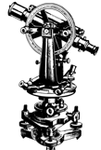
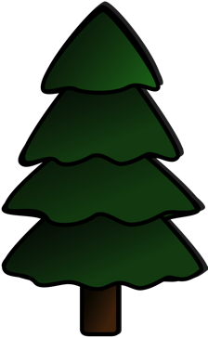
13 m
t m
1.2 m
102°

The theodolite is pointed at the top of the tree.
An angle of 102° is measured from the vertical.

Work out the height of the tree.
[HC, 4 marks]

Answer |  | m

24 An approximate solution to an equation is found using this iterative process.

$x_{n+1}=\frac{{(x_{n})}^{2}+3}{5}$ and $x_{1}=1$

24 a) Work out the values of $x_{2}$ and $x_{3}$
[HC, 2 marks]

$$x_{2}=$$
$$x_{3}=$$

24 b) Work out the solution to 6 decimal places.
[HC, 1 mark]

$$x=$$

25 Jack is assembling a storage unit for CDs.

The unit has six shelves.
Each shelf of the unit is 18 cm wide to the nearest centimetre.

A jewel CD case is 10 mm wide to the nearest millimetre.

Explain why Jack may not be able to fit 100 CD cases in the unit.
[HN, 4 marks]

26 Copper costs £3.20 per kilogram.
Tin costs £1.40 per kilogram.
Bronze is made using copper and tin in the ratio 9 : 1.

Work out the cost of the metal needed when making 45 kilograms of bronze.
[FHN, 4 marks]

Answer £

27 To complete a task in 14 days a building company needs

6 builders each working for 6 hours a day.

The company decides to use

7 builders each working for 8 hours a day.

Assume that each builder works at the same rate.

27 a) How many days will the task take to complete?
You must show your working
[HN, 3 marks]

Answer

27 b) Comment on how the assumption affects your answer to part (a).
[HN, 1 mark]

28 Here is a quadratic sequence

7 18 33 52

The expression for the nth term of this sequence is an² + bn.
Find the value of a and the value of b.
[4 marks]

$$a=$$ |  | $$b=$$

29 The nth term of a sequence is 4n – 1
The nth term of a different sequence is 3n + 2

Work out three numbers that are
in both sequences
and
less than 100
[FHN, 3 marks]

Answer | __________, __________ and __________
30 In this question all dimensions are in centimetres.
A solid has a uniform cross-section.
The cross-section is a square and a quadrant joined together.

2y
2y
y

Work out an expression, in cm³, for the total volume of the solid.
Write your expression in the form y³(a + bπ) where a and b are integers.
[HN, 4 marks]

Answer |  | cm³

31 Colin is solving a problem.

Cuboid A has side lengths one third of the lengths of cuboid B
Cuboid A has a volume of 30 cm³
What is the volume of cuboid B?

To solve this problem, Colin decides to
- Find the value of 3 cubed
- Multiply his answer by 30

Evaluate Colin’s method.
[HN, 2 marks]

32 The region R satisfies three inequalities
$$x≥-2$$ | $$x+y<4$$ | $$y≤\frac{x}{2}+1$$

Show the region R on the grid.
[HC, 4 marks]
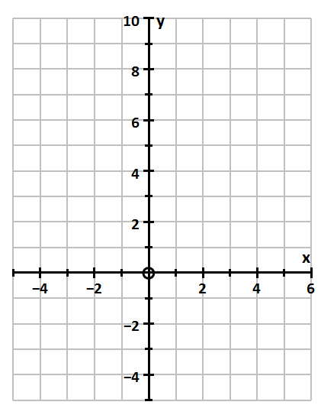
33 Which sequence is a geometric progression?
Circle your answer
[FHC, 1 mark]

1 1 2 3 | 2 5 9 14
2 4 6 8 | 100 50 25 12.5

34 A company analyses its workforce and realises that

number of men : number of women = 3 : 5

There are 38 more women than men.

Work out the total number of people on the workforce.
[FHC, 3 marks]

Answer

35 y is inversely proportional to x.

Which graph shows this?
Circle the correct letter.
[FHC, 1 mark]

A | B
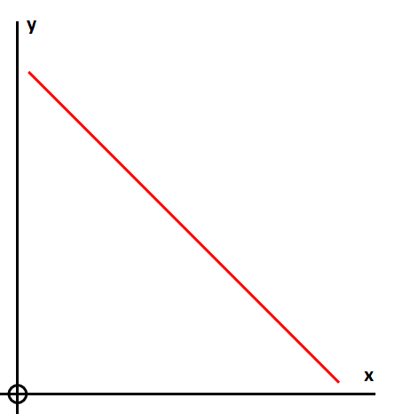 | 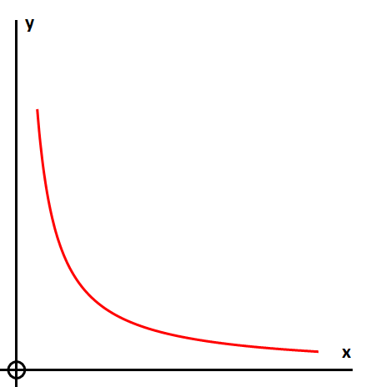
C | D
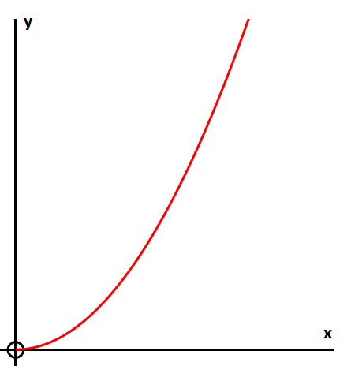 | 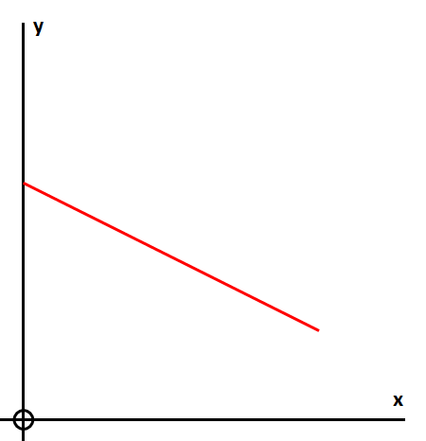

36 Two similar pyramids have heights in the ratio 9 : 2
Circle the ratio of their surface areas.
[HC, 1 mark]

81 : 4 | 18 : 4 | 9 : 2 | 729 : 8

37 Here is a pyramid

13.6 cm
15.2 cm
15.2 cm

Volume of pyramid = $\frac{1}{3}$ × area of base × perpendicular height

Work out the volume of the pyramid
[FC, 3 marks]

Answer |  | cm³

38 A food producer creates a new snack called ‘Dilwyn Dippers’.
A standard size packet contains 80 grams of snack.

They have two ideas for a special offer:

Option 1  30% extra free |  | Option 2  25% off usual price

Which option is the better value for the customer?
You must show your working.
[HC, 3 marks]

Answer

39 a) A pattern is made from two similar trapeziums.
Not drawn accurately

20 cm
20 cm
20 cm
8 cm

Show that the shaded area is 235.2 cm²
[FHC, 4 marks]

39 b) The trapeziums are isosceles.
Not drawn accurately

20 cm
20 cm
20 cm
8 cm
x°

Work out the size of angle x.
[HC, 3 marks]

Answer |  | degrees

40 A bowl is a hemisphere with radius 8 cm.
Water fills three-fifths of the volume of the bowl.

The water is poured into a hollow cone.
The depth of the water is 18 cm.
18 cm

Volume of sphere = $\frac{4}{3}πr^{3}$ where r is the radius
Volume of cone = $\frac{1}{3}πr^{2}h$ where r is the radius and h is the perpendicular height

Work out the radius of the surface of the water in the cone.
[HC, 4 marks]

Answer |  | cm

41 y is directly proportional to x²

x | 2 | a
y | 1 | 25

Work out the value of a.
[HC, 4 marks]

Answer

42 Here are the first five terms of a quadratic sequence

2 7 14 23 34

Find an expression, in terms of n, for the nth term of this quadratic sequence
[4 marks]

Answer

