GRAPHS
D
Pythagroas
GRADE BUSTER

Your ‘5 a day’ mathematical workout

1. a) Complete the table of values for y = 3x – 2.
y | -2 | -1 | 0 | 1 | 2 | 3
x |  |  | -2 |  | 4

b) On the axes, draw the graph of y=3x -2
2. Match the graphs with the correct equations:
x=3
y=x+3
y=x-3
x+y=3
y=3x
y=3
3. a) Find the equations of 3 different linear graphs with a gradient of 2.
b) Find the equations of 3 different linear graphs that pass through -3 on the y axis.
c) Find the equations of 3 different linear graphs that pass through the point (-2,3).

4. i) Explain what is wrong with the following solution:
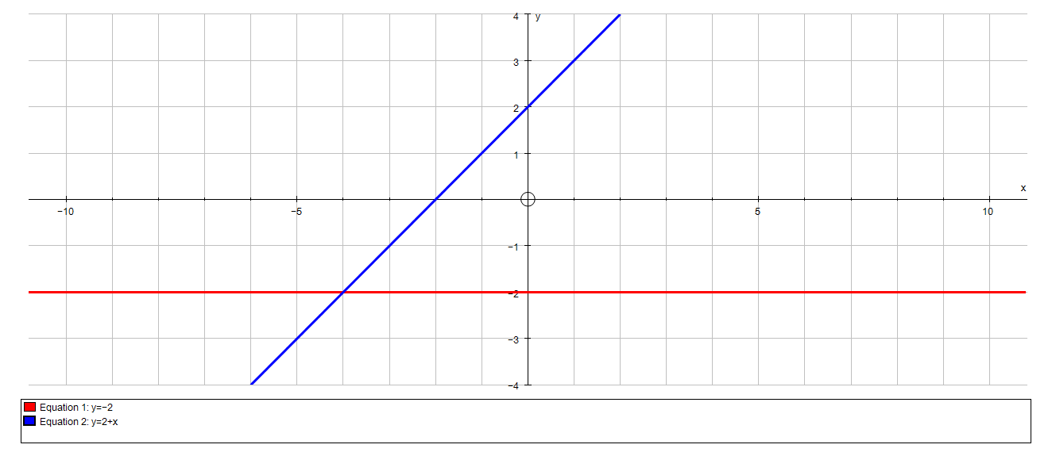
On the axes, draw the graph of:
i) x=-2 ii) x + y = 2
ii) Find the correct solution

5) Matt leaves home at 0800 and travels
10km in 15 minutes. He the stops for ½
an hour before returning home at a speed
of 60km/h.

a) Draw a distance time graph for Matt’s journey.

b) At what time does Matt arrive home?

Qu
1a | I can complete a table of values
1b & 4 | I can draw linear graphs
2 & 3 | I can find the equation of linear graphs
5 | I can draw and interpret distance time graphs

Top tips I must remember for the exam:
Types of questions I need to practise more:

