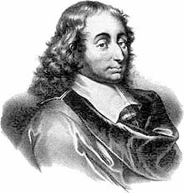
Blaise Pascal (1623 – 1662) was a French mathematician who did a lot in a short life. In his 39 years he managed to invent (amongst other things) the one-wheel wheelbarrow, probability and public transport. He was also closely involved with the construction of the world's first sandwich. However, his work on probability (with a friend called Fermat) made him particularly famous and he ended up having a computer language named after him.

As part of his work on probability he used an ancient Chinese triangle which can easily be built by adding numbers together. You can see the first few rows completed in the diagram below. To fill in a space, add the two numbers diagonally above it.

Although the triangle originated in China it has become known in the West as 'Pascal's Triangle'.

- Complete the diagram down as far as 'Row 12'
- What do you notice about the numbers in 'Diagonal 2'?
- What do you notice about the sums of the numbers in each row?
- What do you notice about the number of odd numbers in each row?
- What do you notice about the numbers in the prime-numbered rows?
- Diagonal 3 shows the tetrahedral numbers (1, 4, 10, 20, …) These are sometimes called cannonball numbers. Can you find out why?

Further ideas:
- The Fibonacci numbers can also be found in Pascal’s triangle (1, 1, 2, 3, 5, 8, 13, …) Find out how these numbers can be found within the triangle.
- Find out more about Blaise Pascal and prepare a presentation to the class.
- Program a spreadsheet to generate Pascal’s Triangle
- If you highlight all the multiples of three in Pascal’s triangle, the following fractal pattern emerges. Find out more about fractal patterns, and investigate whether any other such patterns can be created using the triangle as a starting point.

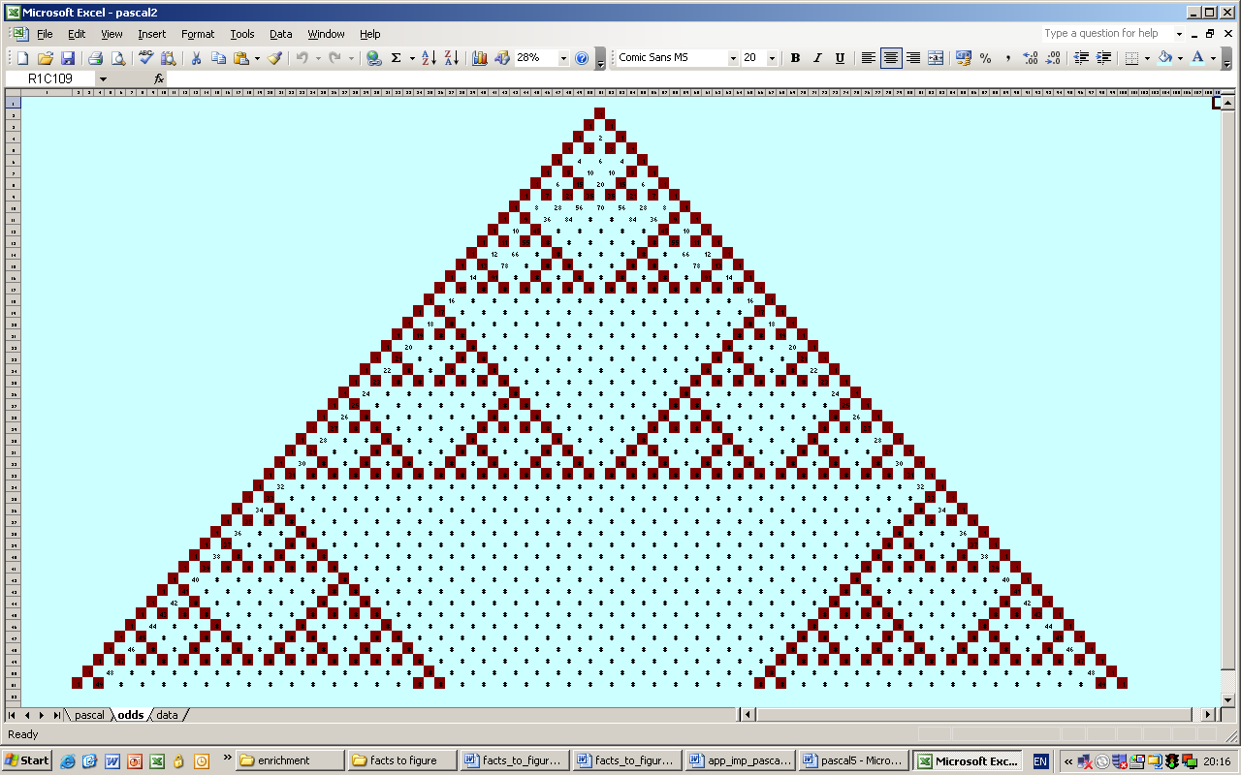

Interesting quotes from Mr. Pascal:

‘All of man’s troubles come from his not knowing how to sit still.’

‘There is a God-shaped vacuum in the heart of every man.’

