When you are asked questions, write down the solutions in your exercise books, OR in a Word document that can be printed off later.

Introduction: Autographing transformations

The activities here will help you understand how to use Autograph to carry out some transformations. You need this skill for the main event later on.

Reflection
- Open your Autograph template.
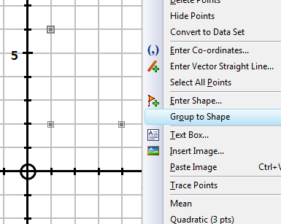
- Select the ‘point mode’ from the left-hand menu. You can now left-click to plot a point on the grid.
- Plot three points at (1,2), (4,2) and (1,6)
- Now choose ‘select mode’ . Hold down ‘Shift’, and click on all three points to select them.
- Right-click, and choose ‘Group to Shape’ from the menu. This will draw a triangle.

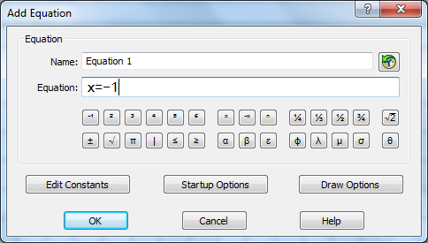
- Now plot your mirror line. Press ‘Return’ to access the ‘Add Equation’ menu. Type ‘x=-1’ into the space. Click OK to plot the line.
- Using ‘select mode’ (and holding down ‘Shift’) select both the triangle and the line.

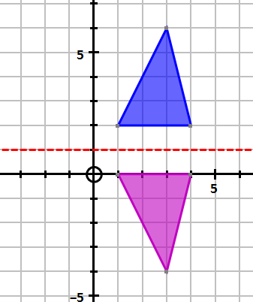
- Right-click, and choose ‘Reflection’. Autograph will reflect your triangle in the mirror line. Write down the coordinates of the vertices of the image.
- Experiment 1: Click and drag any vertex of the object triangle. Observe the impact on the image.
- Experiment 2: Try varying the equation of the mirror line.
- Choose ‘Page > Copy Page’. Paste this in to a Word document (but don’t print till the end of the lesson!)

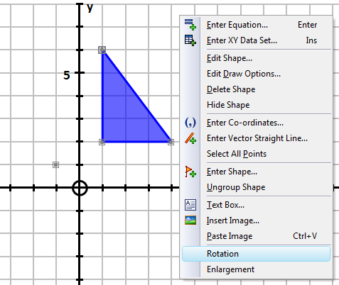
Rotation
- Open another Autograph template.
- Make sure that degrees mode is selected on the top menu
- Draw a triangle exactly as before.
- Use ‘point mode’ to plot a point at (-1,1)
- You are now going to rotate this triangle 90° anticlockwise about the point (-1,1). Select the triangle and the point. Right-click and choose ‘Rotation.
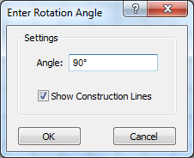
- Autograph always rotates anticlockwise. Check that 90° is entered as the angle. You might prefer to deselect ‘show construction lines’. Click OK. Write down the coordinates of the vertices of the image.
- How would you instruct Autograph to carry out a 90° clockwise rotation?
- Experiment 1: Click and drag any vertex of the object triangle. Observe the impact on the image.
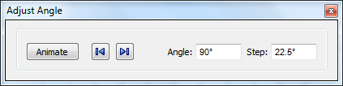
- Experiment 2: Select the image. Now select the animate option from the top menu. Vary the angle of rotation and observe the impact.
- Paste an example of a rotation in to your Word document
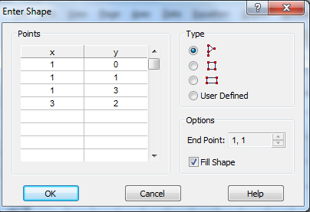
Enlargement
- Open another Autograph template.
- This time, choose to pre-select a shape from the top menu .
- Choose the flag (first option) and click OK
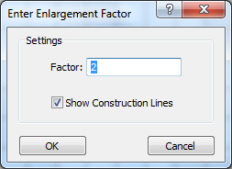
- Mark a point at (-1,2). This will be your centre of enlargement.
- Select the point and the flag. Right-click and choose ‘Enlargement’.
- Keep the scale factor as 2, and leave in the construction lines. Click OK. Write down the coordinates of the vertices of the image.
- Experiment 1: Click and drag the centre of enlargement. Observe the impact on the image.
- Experiment 2: Select the image. Now select the animate option from the top menu. Vary the scale factor and observe the impact (KEEP THE SCALE FACTOR GREATER THAN 1!)
- Paste an example of an enlargement in to your Word document

The Main Event I: Reflecting and Rotating

- Construct a triangle (A) with coordinates A (1,1), B (2,1) and C (2,3).
- Reflect this triangle in the line x = 4. Call this triangle B.
- Now reflect triangle B in the line y = x. Call this triangle C.
- Write down the coordinates of triangle C.
- Now return to the original triangle (A). Your challenge is to rotate this triangle so that it is moved onto triangle C. Describe the rotation that you have carried out.
- What do you notice about this centre of rotation? Investigate. Write down what you notice using diagrams to help.

The Main Event II: Extending Enlargement
- Construct a rectangle from the pre-selected shapes .
- Use a centre of enlargement at (-2,1) to enlarge the rectangle with scale factor 2.
- Now select the animate option and vary the scale factor again. This time, reduce the scale factor below 1, and then below 0.
- Observe the impact of a negative scale factor. Write about what you notice using diagrams to help.
- Repeat your experimenting using the pre-selected flag and a negative scale factor.

