Find the circumference of this circle  8 cm | The radius of a circle is 6 mm  r = 6 mm  Find the circumference of the circle
The circumference of a circle is 30 cm  Work out the diameter of the circle | The circumference of a circle is 40 m  Work out the radius of the circle
A semicircle has diameter 12 cm  Find the perimeter of the semicircle  12 cm | The quadrant has a radius of 8 cm  Find the perimeter of the quadrant  8 cm
The Winchester Round Table dates from 1290. It has a diameter of 5.5 metres. There are equal spaces for 24 knights to sit around the table.  What (arc) length did each knight have in which to sit? Give your solution in centimetres. | The diameter of a bike wheel is 67 cm  How many times does it turn in 120 metres?  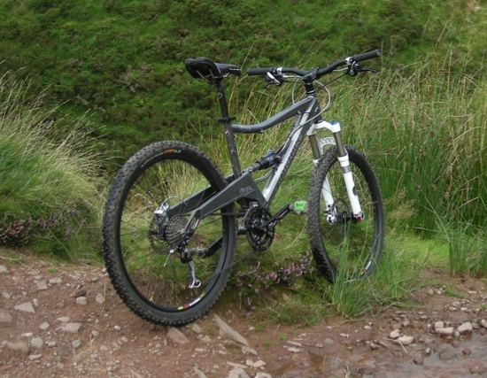

- Solve each of the circle problems on page 1

- The answers are shown here. They are jumbled up. You need to match each problem to its solution.

6.4 | 25.1
57.0 | 37.7
9.5 | 28.7
72.0 | 30.8
answers have been rounded to one decimal place

- Write up each problem in your book. Make sure that you clearly explain each step of the working.

- The units of the answer are not shown. In your solution, you need to find the correct unit too.

- What other problems could you solve using these shapes?

