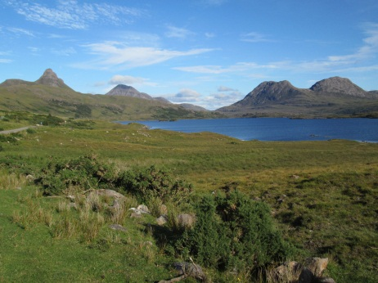
Key vocabulary:
- Enlargement
- Scale factor
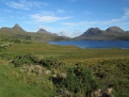
- Centre of enlargement
- Object
- Image

Task One
Work out the scale factor for each of these enlargements

Scale factor: _______ | Scale factor: _______
Scale factor: _______ | Scale factor: _______

There are two more on the next page …
Scale factor: _______ | Scale factor: _______

Explain how you found the scale factor of these enlargements

Task Two
Now, find the position of the centre of enlargement in each case

Centre of enlargement: (______, ______) | Centre of enlargement: (______, ______)

There are four more on the next page …
Centre of enlargement: (______, ______) | Centre of enlargement: (______, ______)
Centre of enlargement: (______, ______) | Centre of enlargement: (______, ______)

Explain how you found the centre of enlargement

Task Three: the main event

Use your observations to work out where the image is in each of these enlargements

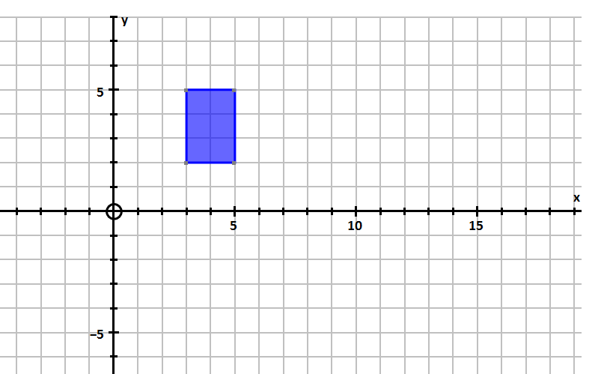
Scale factor: 2

Centre of enlargement: (1, 4)

Scale factor: 3

Centre of enlargement: (5, 4)

Scale factor: 4

Centre of enlargement: (-6, -4)

