Reflection: Flip it!  To describe in full you need:  - The equation of the mirror line; e.g. x = -2  Hints:  - You are not allowed a mirror in an exam. Use folded tracing paper.  - If the mirror line is diagonal, turn your page to make it vertical | Rotation: Twist it!  To describe in full you need:  - The centre of rotation; e.g. (4,1)  - The angle of rotation; e.g. 90°  - The direction of rotation; e.g. clockwise  Hints:  - Ask for tracing paper
Translation: Slide it!

To describe in full you need:
- The number of squares moved up/down
- The number of squares moved left/right
- State this using a vector; e.g. $\left(\begin{matrix}7 \\ -3\end{matrix}\right)$

Hints
- Ask for tracing paper
- Draw the vector to check

Reflect A in the line x = -1 | Reflect A in the line y = 3
Reflect A in the line y = x | Reflect A in the line x = 2
Reflect A in the line y = 3 | Reflect A in the line y = -x

Rotate A 90° clockwise about (2,1) | Rotate A 90° anticlockwise about (1,0)
Rotate A 180° about (0,0) | Rotate A 90° clockwise about (1,3)
Rotate A 270° clockwise about (3,2) | Rotate A 90° anticlockwise about (2,-1)
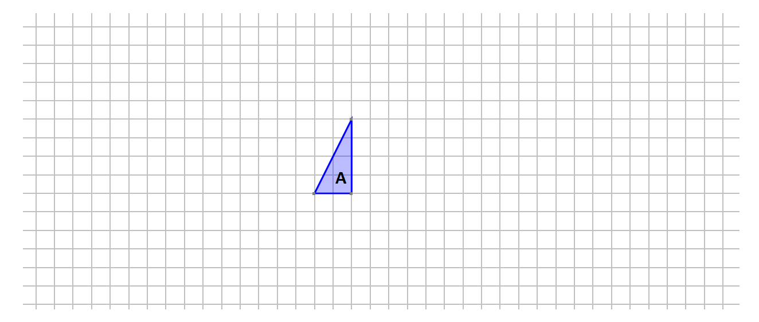
Translate A by the vector $\left(\begin{matrix}5 \\ 2\end{matrix}\right)$. Label the image B.

Translate A by the vector $\left(\begin{matrix}1 \\ 4\end{matrix}\right)$. Label the image C.

Translate A by the vector $\left(\begin{matrix}-5 \\ 3\end{matrix}\right)$. Label the image D.

Translate A by the vector $\left(\begin{matrix}-1 \\ -3\end{matrix}\right)$. Label the image E.

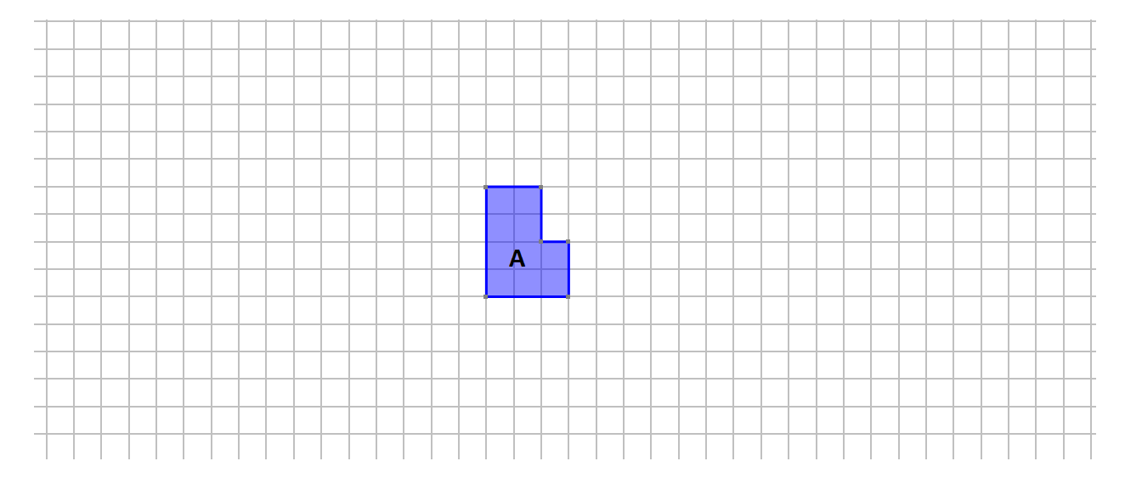
Translate A by the vector $\left(\begin{matrix}2 \\ 6\end{matrix}\right)$. Label the image B.

Translate A by the vector $\left(\begin{matrix}4 \\ -1\end{matrix}\right)$. Label the image C.

Translate A by the vector $\left(\begin{matrix}-5 \\ -3\end{matrix}\right)$. Label the image D.

Translate A by the vector $\left(\begin{matrix}-6 \\ 3\end{matrix}\right)$. Label the image E.

