Graph to show men’s 100-metre world record progression

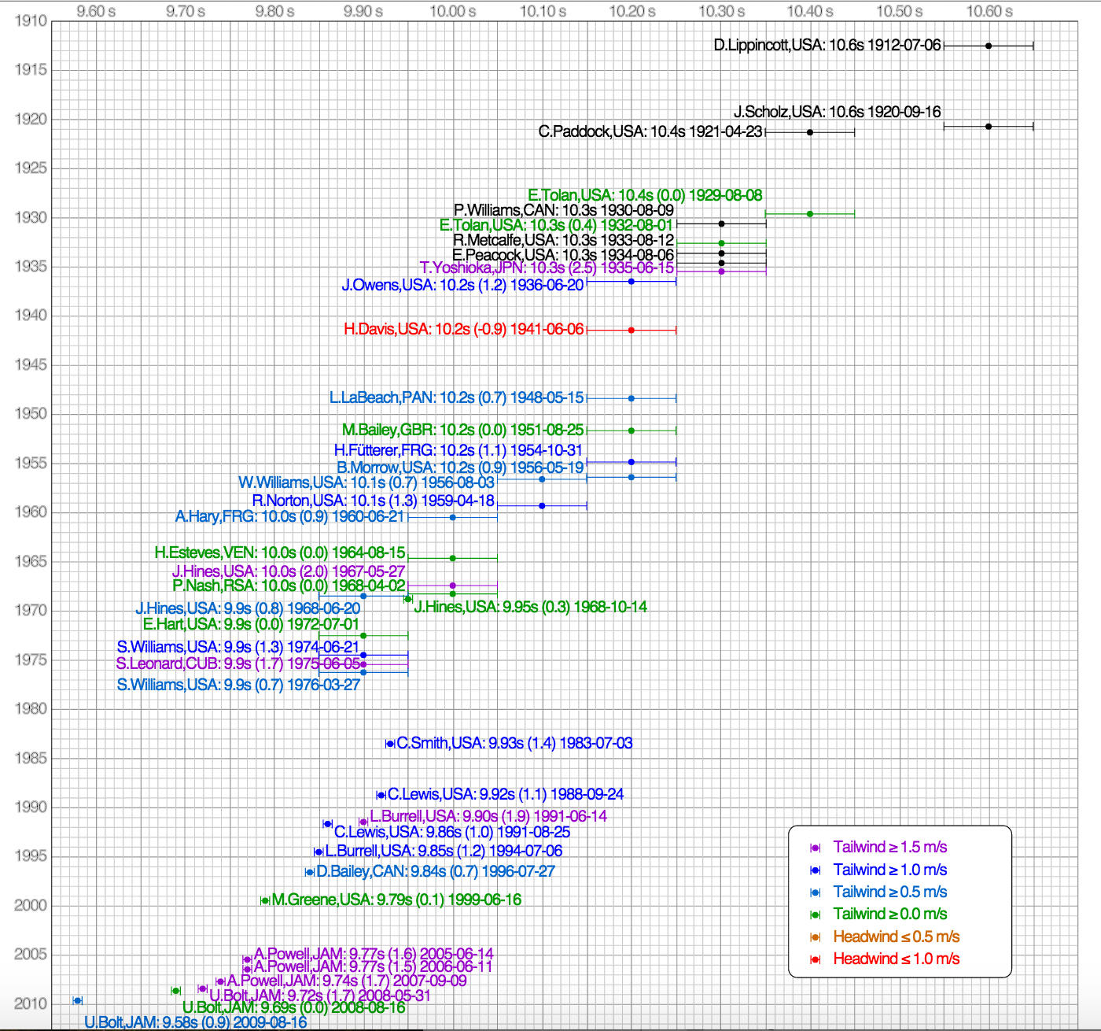

By Cmglee - own work, CC BY-SA 3.0, https://commons.wikimedia.org/w/index.php?curid=17975990

In pairs:

- What was Donald Lippincot’s world record time, set in 1912?
- What is Usain Bolt’s current world record time, set in 2009?
- Write down information about three world records set before 1977
- Write down information about three world records set after 1977
- What do the ‘whiskers’ mean?

If it helps, an alternative graph of the same data is on the other side

Same data, different representation …

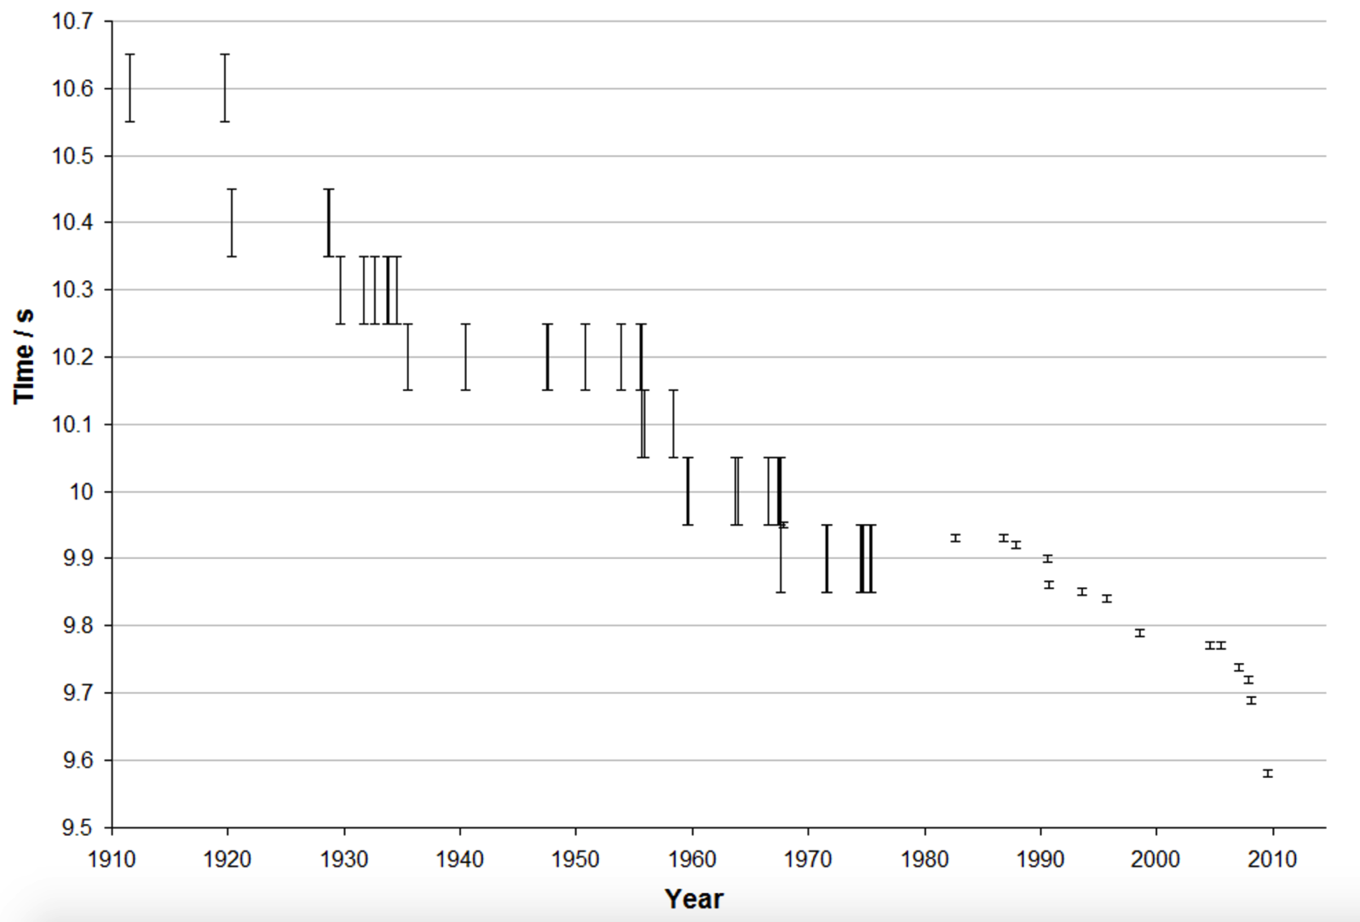

source: http://en.academic.ru/

Time Athlete Nationality Date  10.6 Donald Lippincott United States July 6, 1912  Jackson Scholz United States September 16, 1920  10.4 Charlie Paddock United States April 23, 1921  Eddie Tolan United States August 8, 1929  10.3 Percy Williams Canada August 9, 1930  Eddie Tolan United States August 1, 1932  Eulace Peacock United States August 6, 1934  Chris Berger Netherlands August 26, 1934  Takayoshi Yoshioka Japan June 15, 1935  10.2 Jesse Owens United States June 20, 1936  Harold Davis United States June 6, 1941  Lloyd LaBeach Panama May 15, 1948  Barney Ewell United States July 9, 1948  McDonald Bailey Great Britain August 25, 1951  Heinz Fütterer West Germany October 31, 1954  Bobby Morrow United States May 19, 1956  Ira Murchison United States June 1, 1956  10.1 Willie Williams United States August 3, 1956  Ira Murchison United States August 4, 1956  Leamon King United States October 20, 1956  Ray Norton United States April 18, 1959  10.0 Armin Hary West Germany June 21, 1960  Harry Jerome Canada July 15, 1960  Horacio Esteves Venezuela August 15, 1964  Bob Hayes United States October 15, 1964  Jim Hines United States May 27, 1967  Enrique Figuerola Cuba June 17, 1967  Paul Nash South Africa April 2, 1968  Oliver Ford United States May 31, 1968  Charles Greene United States June 20, 1968  Roger Bambuck France June 20, 1968  9.9 Jim Hines United States June 20, 1968  Ronnie Ray Smith United States June 20, 1968  Charles Greene United States June 20, 1968  Eddie Hart United States July 1, 1972  Rey Robinson United States July 1, 1972  Steve Williams United States June 21, 1974  Silvio Leonard Cuba June 5, 1975  Harvey Glance United States April 3, 1976  Don Quarrie Jamaica May 22, 1976 |  | Time Athlete Nationality Date  9.93 Calvin Smith United States July 3, 1983  9.92 Carl Lewis United States September 24, 1988  9.90 Leroy Burrell United States June 14, 1991  9.86 Carl Lewis United States August 25, 1991  9.85 Leroy Burrell United States July 6, 1994  9.84 Donovan Bailey Canada July 27, 1996  9.79 Maurice Greene United States June 16, 1999  9.77 Asafa Powell Jamaica June 14, 2005  9.74 Asafa Powell Jamaica September 9, 2007  9.72 Usain Bolt Jamaica May 31, 2008  9.69 Usain Bolt Jamaica August 16, 2008  9.58 Usain Bolt Jamaica August 16, 2009  source: en.wikipedia.org

100 metres

The US athlete, Jesse Owens, once broke four different world records within 45 minutes at the same athletics event. A year later, during the 1936 Berlin Olympics, he won four gold medals.

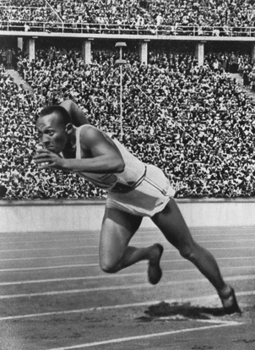  Public domain | - What was the lower bound of Owens’ record 100-metre time?  - What was the upper bound of his time?  - Write the error interval for Jesse Owens’ 1936 world record  - Write the error interval for Willie Williams’ 1956 world record  - Write the error interval for Donovan Bailey’s 1996 world record  - June 20 1968 is known as the ‘Night of Speed’ as three runners broke the world record at the same event. Was this the first time that a person had run 100 metres in less than 10 seconds? Explain your answer.
Need more practice before moving on? Write down some more error intervals using the information in the tables.

Tallest and shortest  The tallest man who ever lived, Robert Wadlow, was 2.72 metres tall to the nearest centimetre. Write the error interval for his height.  The shortest man who has ever lived, Chandra Bahadur Dangi, was 54.6 centimetres tall to the nearest millimetre. Write the error interval for his height. | Mount Everest  When Mount Everest was first surveyed during the Great Trigonometric Survey of the 1850s, it was found to be exactly 29,000 feet high.  It had taken years to find this result, and the surveyors were worried that people would think they had only estimated. So instead, they announced that Everest’s height was 29,002 feet.  Imagine that 29,000 had been estimated to the nearest 1000 feet. What would the highest and lowest possible heights be? Write the error interval for this measurement.  (Mount Everest is now thought to be 29,029 feet high)
Kitchen cabinets  A kitchen cabinet has a width of 600 mm ±2 mm. Write the error interval for the width of the cabinet.  Georgina is designing a new kitchen. She wants to place 5 of these cabinets alongside each other on a wall that is 3 metres long. Will the cabinets fit? Explain your reasoning. | Van  A van can safely transport a load of 800 kg. Andy is using the van to carry sacks of sand. Each sack has a mass of 25 kg to the nearest kg.  How many sacks of sand can Andy transport safely? Explain your thinking.

Fibonacci Rectangle
5 cm
8 cm
The Fibonacci number sequence starts with the numbers 1, 1, …

Each term is found by adding the two previous terms.

The sequence continues as follows: 1, 1, 2, 3, 5, 8, 13, 21, …

The dimensions of a rectangle are measured to the nearest centimetre.
It is noted that they are two consecutive Fibonacci numbers: 5 cm and 8 cm.

Problem

- Find the upper bound for the area of the rectangle
- Find the lower bound for the area of the rectangle
- Find the difference between the upper and lower bounds for the area of the rectangle.

- Use your answer to form a conjecture. Explore further. Write down your results.

- Place the following statements in order to prove the conjecture

The bounds of b are b – 0.5 and b + 0.5
The difference between the bounds of the area is
(ab + 0.5a + 0.5b + 0.25) – (ab – 0.5a – 0.5b + 0.25) = 0.5a + 0.5a + 0.5b + 0.5b = a + b
The upper bound of the area is (a + 0.5)(b + 0.5) = ab + 0.5a + 0.5b + 0.25
The bounds of a are a – 0.5 and a + 0.5
Since a and b are two Fibonacci numbers then a + b is the next Fibonacci number
Let a and b be two consecutive Fibonacci numbers that are the dimensions of a rectangle
The lower bound of the area is (a – 0.5)(b – 0.5) = ab – 0.5a – 0.5b + 0.25

