‘Perfect numbers, like perfect men, are very rare’ (Rene Descartes 1596 - 1650)

Perfection

A perfect number is equal to the sum of its factors, excluding itself.
6 is the first perfect number: 1 + 2 + 3 = 6

The second perfect number is 28.
- Show that 28 is a perfect number.
- Show that 36 is not a perfect number.

36 is an abundant number.
22 is a deficient number.
- Suggest a reason for these names.

Perfect pictures

This diagram shows why 6 is a perfect number.

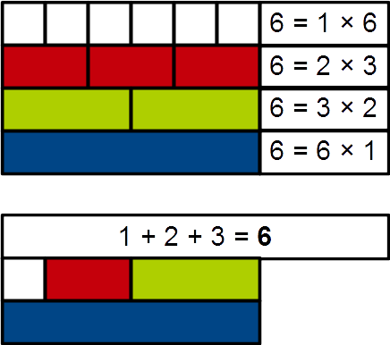
Image: by Hyacinth - own work, CC BY-SA 4.0, https://commons.wikimedia.org/w/index.php?curid=48357566

Create a similar diagram to show why 28 is a perfect number.

Perfect patterns

The first five perfect numbers are:

6, 28, 496, 8128, 33,550,336

Each of these perfect numbers can be written in the form

2^{p – 1}(2^{p} – 1)

For example: if p = 2, then

2^{2 – 1}(2² – 1) = 2¹ × (4 – 1) = 2 × 3 = 6

- Find the value of p for each of the first five perfect numbers.
- What do you notice about the values of p that you have found?

