Remember the following:
- To copy an Autograph page, use ‘Ctrl+C’. To paste this page into Word use ‘Ctrl+V’
- Ensure that your name is included in the footer of any Word files that you print. Do not print direct from Autograph.
- Do not get out of your seat to get things from the printer – I will check regularly and hand them out.

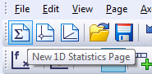
When you first open Autograph it gives you a ‘2D Graphing Page’. To use Autograph for most statistics you need to have a ‘1D Statistics Page’ open. Do this by clicking on the icon shown here:

In this session you need to use the ‘World Statistics’ spreadsheet

Task One: Entering raw data
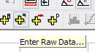
1. You can enter data as a simple list by clicking on ‘Enter Raw Data’.

2. The box below will appear on screen.

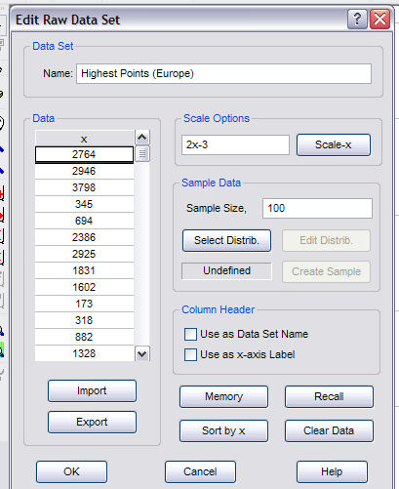
You could now construct box and whisker diagrams and/or dot plots – in the same way as shown on the ‘cumulative frequency’ worksheet.

You can also use Autograph to calculate statistics for you, as shown in the next tasks.
- Copy and paste the data for highest points in Europe from the ‘World Statistics’ spreadsheet.

- Type in a name for the data

- Click on OK
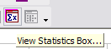
Task Two: Calculating statistics (Using the ‘statistics box’)

1. Click on the icon shown here: ‘View Statistics Box’.

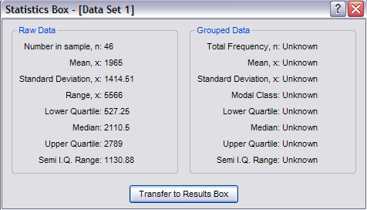
2. The statistics box will open on screen. In this case – as we are using raw data – the left hand box contains several useful statistical measures.

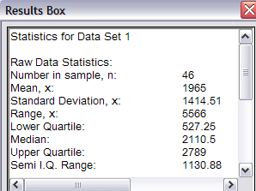
3. To copy this information, first click on ‘Transfer to Results Box’. Then go to ‘View’, ‘Results Box’. You can copy information from here and paste into Word.

NOTE: The semi-interquartile range is half of the interquartile range.

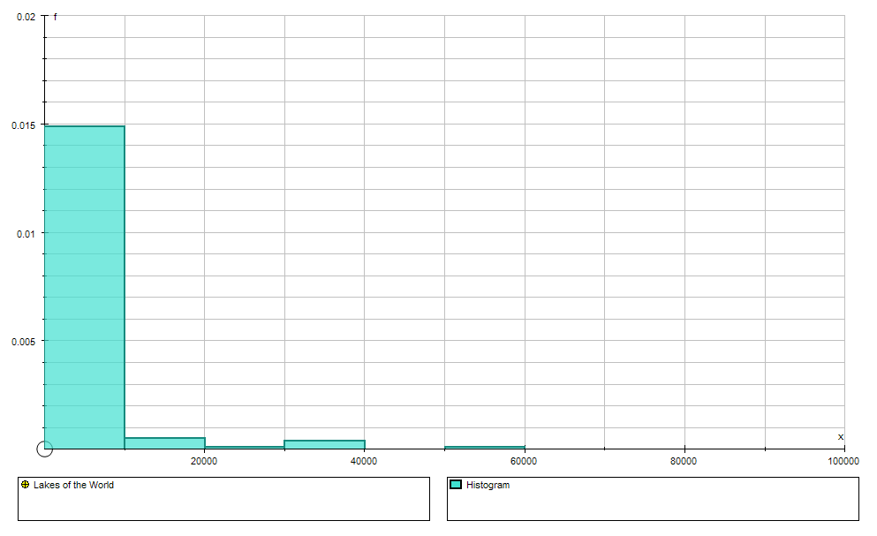
Task Three: Calculating statistics – grouped data (and demonstrating why unequal class widths and careful consideration of the data are sometimes needed)

1. Enter the largest lake data as grouped data in the same way as shown on the ‘cumulative frequency’ worksheet. (‘Enter Grouped Data’, ‘Use Raw Data’, ‘Edit’, copy and paste, ‘OK’).

2. Construct a histogram, and play about with the axes - you will get something like the graph shown on the left. It isn’t very sensible (and a box plot is totally useless – try it and see!)

3. A glance through the original data suggests that it would be sensible to alter the width of the groups. Double click on ‘Data Set 1’ or whatever you chose to call it. Under class intervals choose ‘Enter Manually’. Type ‘0, 250, 500, 1000, 5000, 60000’ into the box, and redraw the histogram. Adjust the scales to get a more sensible graph.
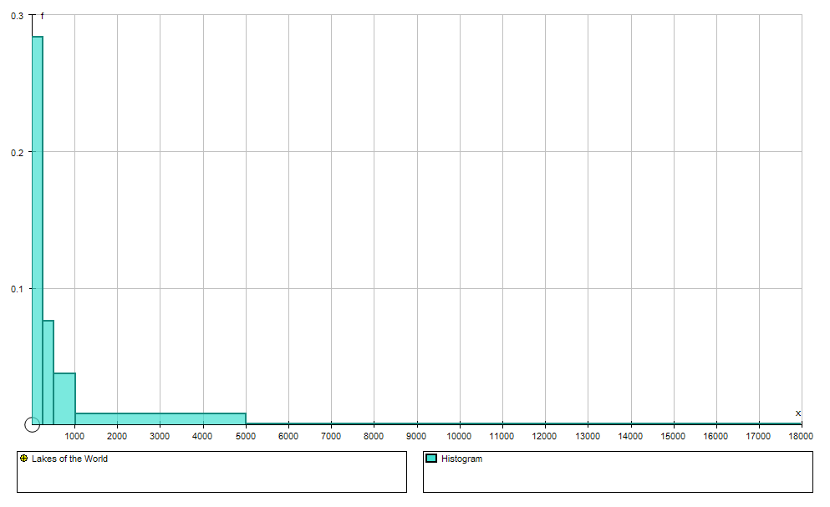
4. However, a dot plot shows that there are some pieces of data having a drastic effect on the graph (Lake Michigan: 57866km², Lake Huron: 36001km², Lake Baykal: 31500km², Lake Victoria: 30960km², Lake Malawi: 24400km²). Delete these obvious outliers from the data set and redraw the histogram again – changing the intervals to ‘0, 250, 500, 1000, 5000, 18000’. You should get a graph similar to the one here:

It is still an unusual graph, but it does show clearly that there are very few lakes with an area greater than 5000km², and the distribution of lakes with areas in the other groups is more clear. Zooming in on the histogram shows this (below left). Compare it with a frequency diagram (below right) which is very misleading

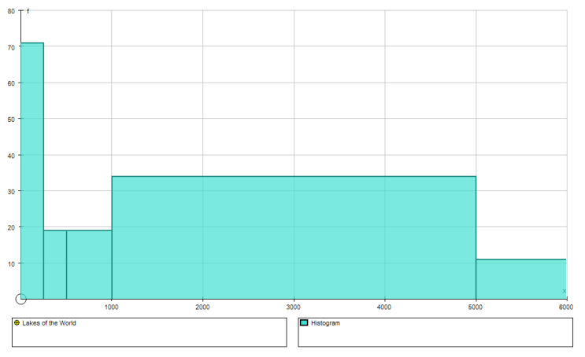
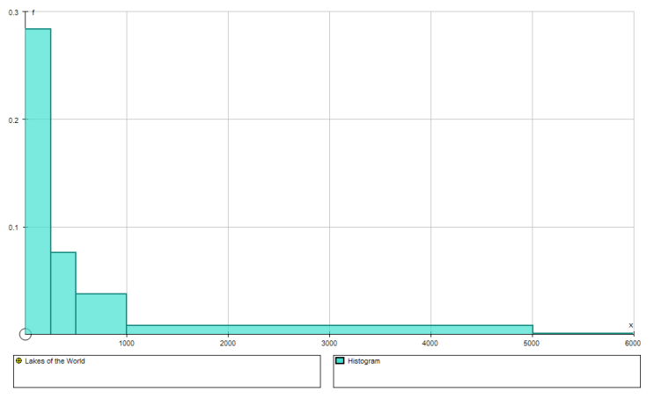

5. The results box will contain relevant statistics again, and will include a grouped frequency table which can be copied into Word.

Task Four

Using the spreadsheet state some hypotheses and test them. Use a variety of graphs and charts to back up your arguments.

